Problem Statement1 Write a Java program, to take a HDFS Path as input and display all the files and sub-directories in that HDFS path.

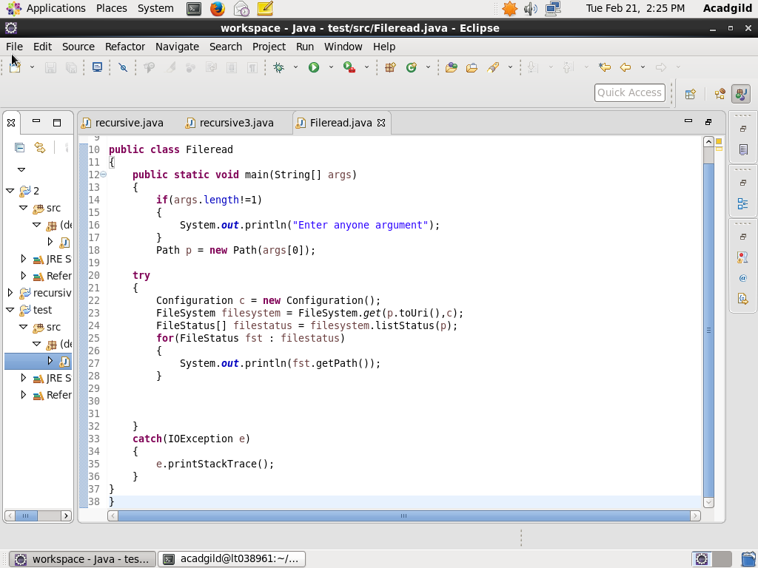

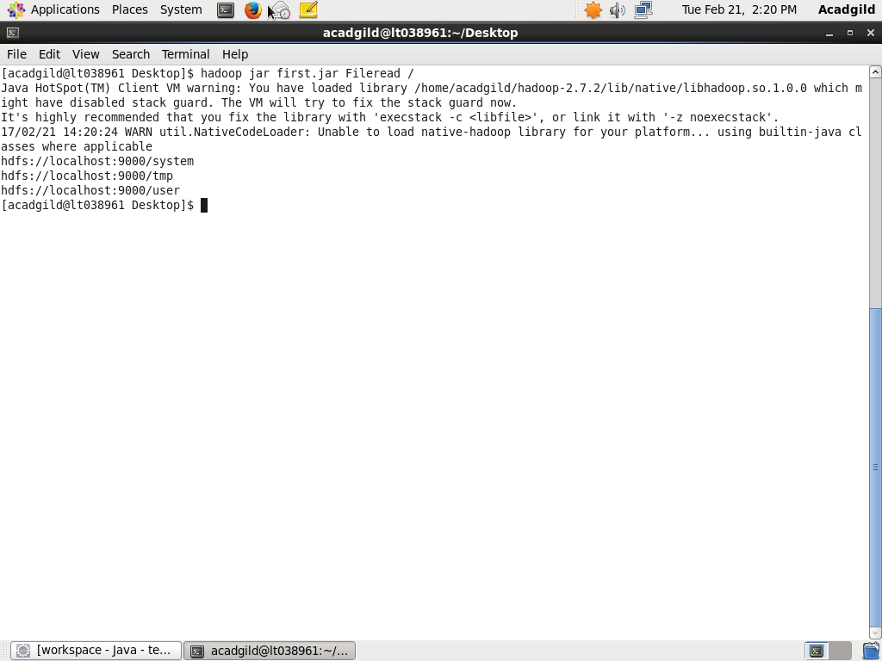

Could not copy from the virtual Machine so sending the screen shot of the code

Problem Statement2 Modify the previous program to list all the files and sub-directories in the HDFS path recursively.

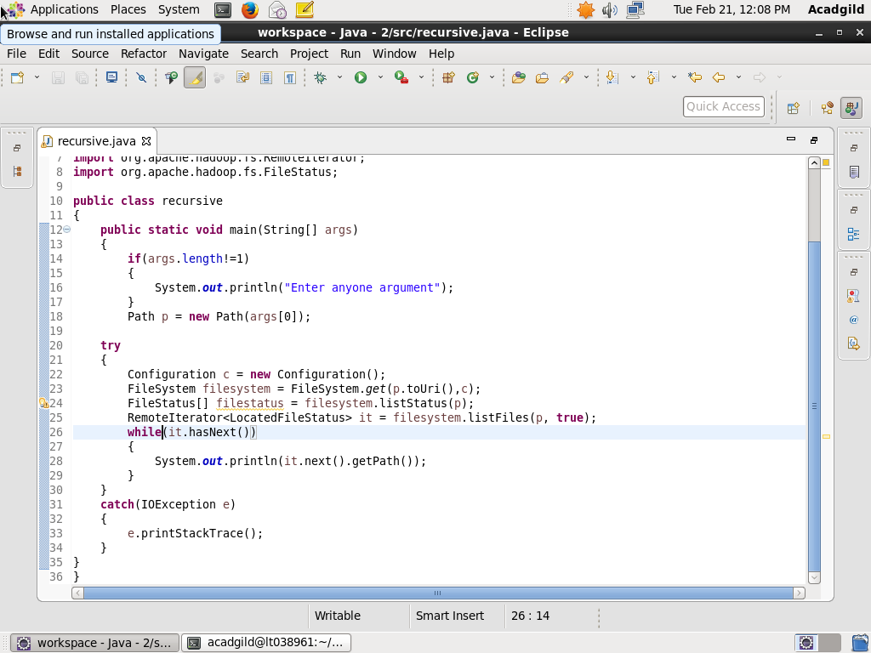

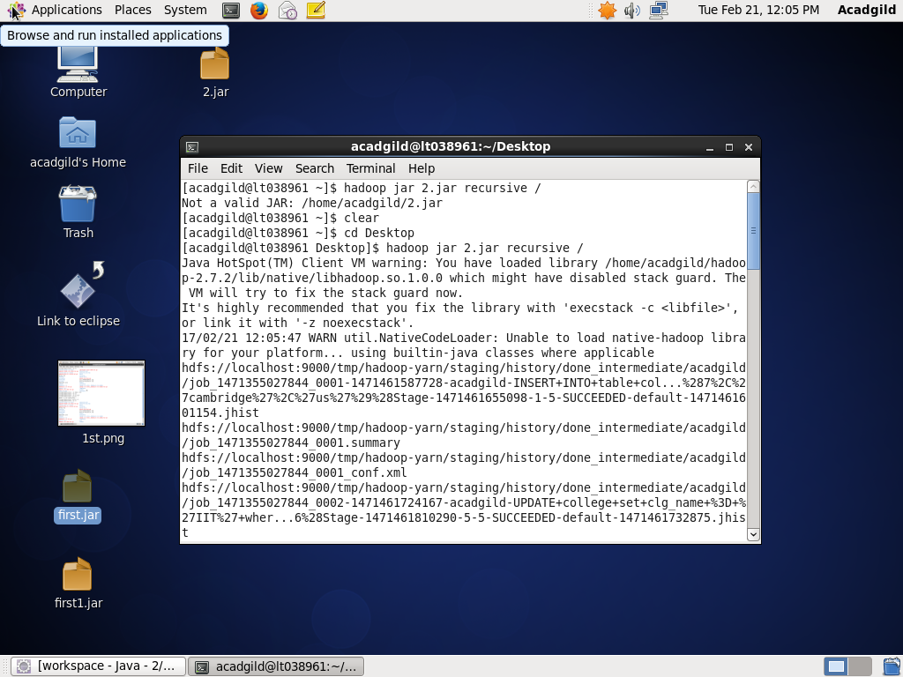

Problem Statement3 Modify the previous program to take multiple HDFS paths (separated by space) and list all the files and sub-directories in those HDFS paths recursively.

